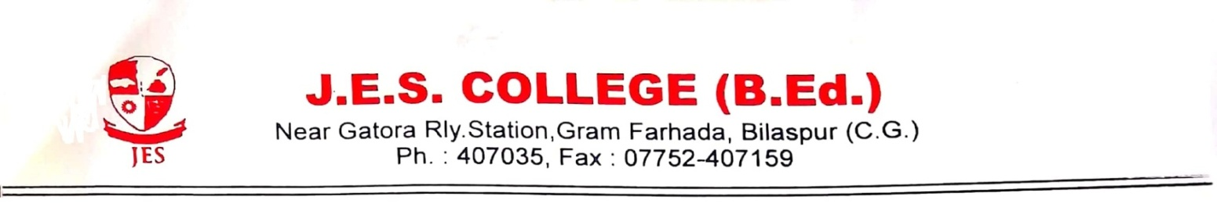

Sample of an RTI Application CONTACT RTI OFFICER :- P.L. PALI
Date:- CONTACT NO. :- 8770714258

To,
The Public Information Officer
Name of the department
Address of the department City (state)
From
Applicant’s name
Postal address
City (state)
Ph:
Subject: Application under Right to Information act, 2005.
Dear Sir,
I would like to get the following information in document/sample/electronic record/inspection form. Please provide the following in specified time limit: -
(1)
(2)
(3)
(4)
I am ready to pay the required fee for the information/I’m a BPL applicant, so please provide the information free of cost.
Encl. - Rs. 10/- application fee. / In case of BPL (Please enclose a proof of BPL or your BPL Card Number)
Thanking You
Yours Sincerely
Applicant’s signature
Applicant’s name

